CREATING SQL DATABASE

1. Select SQL Database from home page

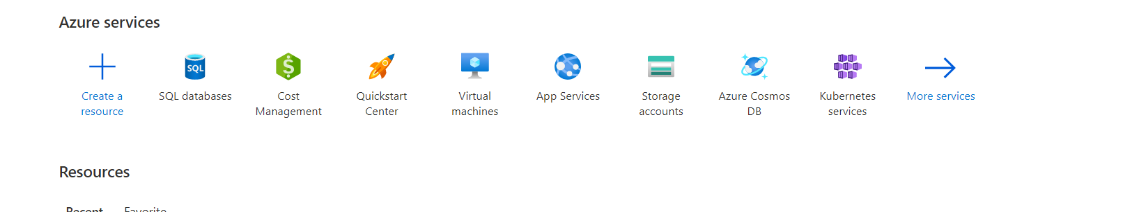

1. Click on Create database

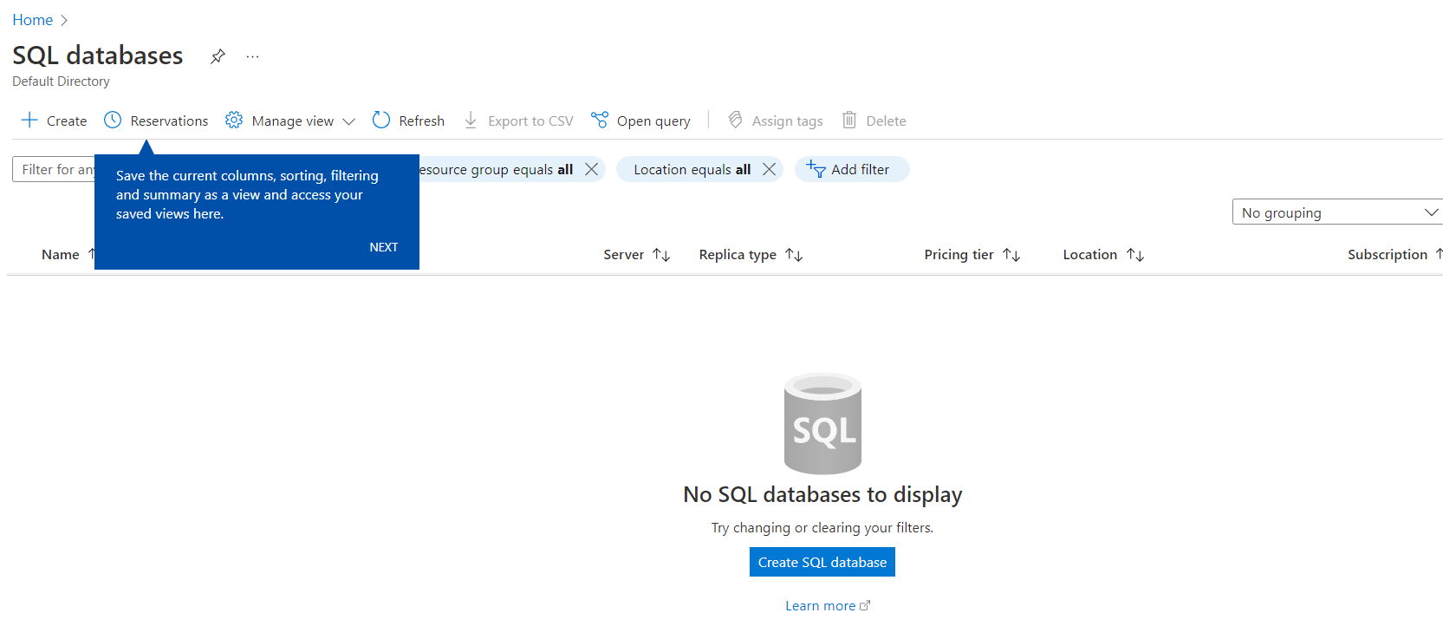

1. Create a resource Group

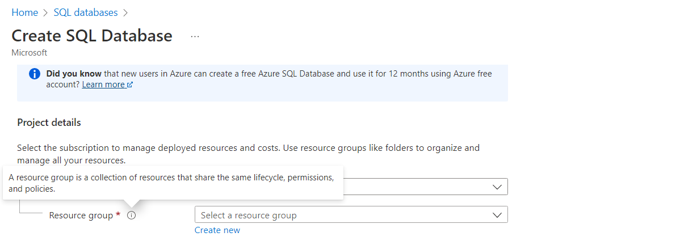

1. Create a new Server

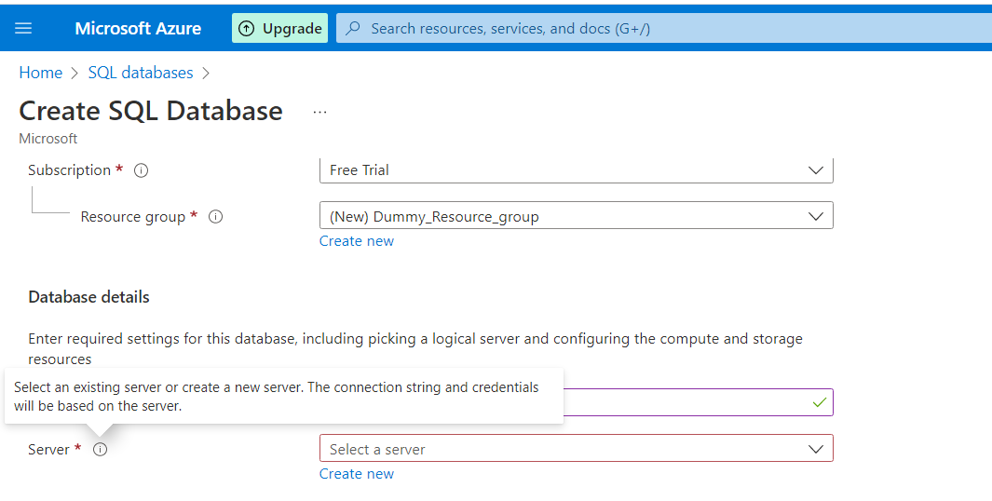

1. Create admin login with creds

***Server name-: dummy-test***

***Login -: demouser/Ss0061933!***

**Select sql authentication method**

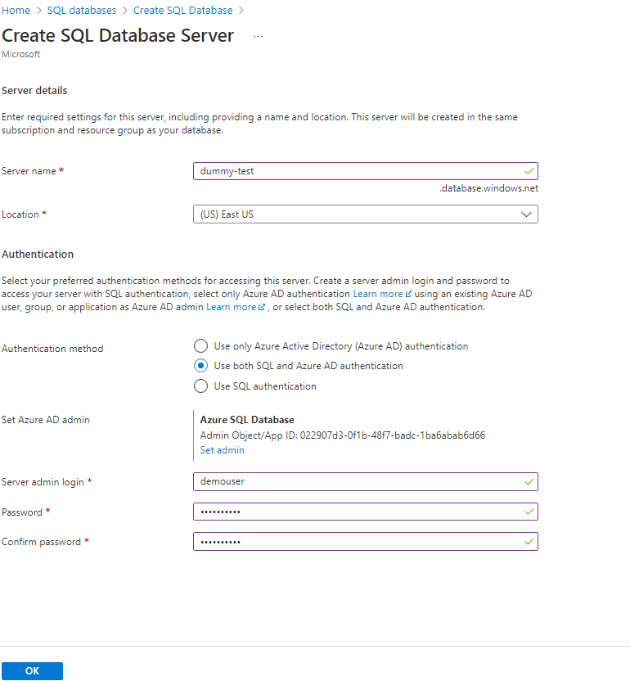

1. Configure network access

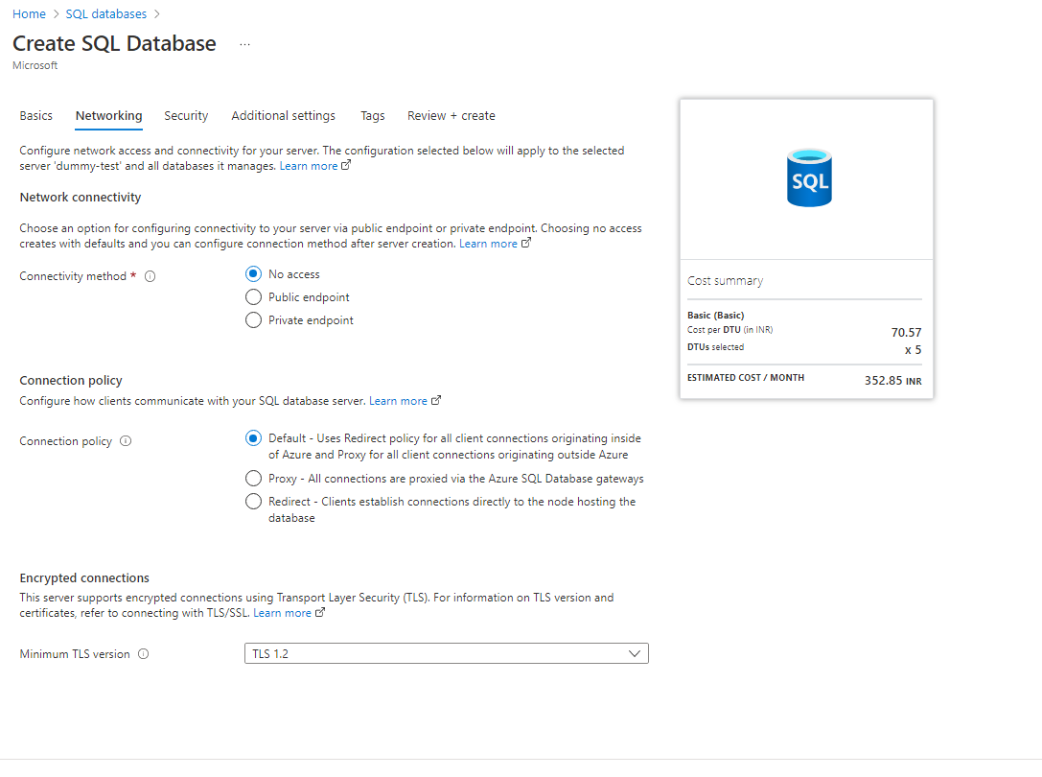

1. Configure the security options

